Project Summary

Project Idea

Smart Mobility is a rising buzz word in the development context of the 21st century to make traveler’s lives easier to manage. Our project addresses the booking process to make travelling more comfortable. An enormous amount of time could be saved for business travellers by taking calendars and letting a program calculate the optimal way time wise and cost wise for travel plans including hotels, taxis, trains and flights, aligned to the company policies. The future customer in smart mobility won’t search for single transport solutions rather than saving time and costs by deciding which travel route suits him best.

Version v0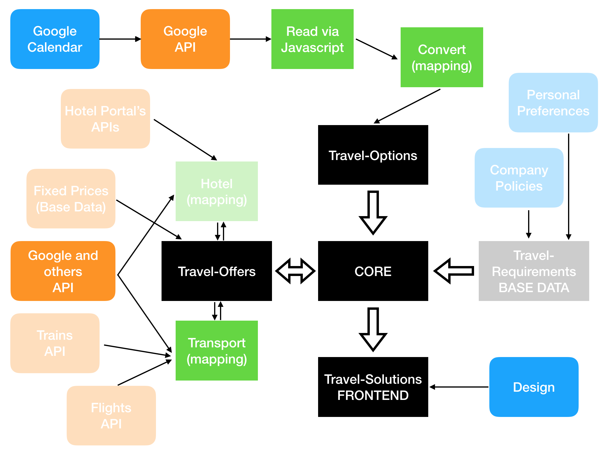

The transparent parts in this map will be released in a possible v1 oder v2. For v0 we implemented some basics for the highlighted modules you could see obove.

We started off, by creating a JS File that accesses Data from Google Calendar via an API, provided by Google. The collected information is being gathered and split into different legs. Each leg contains one travel process. One leg consists of Origin and Destination, containing the starting and ending time and place of the previous and upcoming event. The sum of these legs makes up the Travel-Options.

These Travel Options will be parsed with the Input of various APIs to different ways of travelling but could only deliver a few of the possible solutions to keep the quota limits of the google APIs. With some more specifically defined elements, depending on the form of transportation, we map many different ways of travelling. The customer can choose which he wants to follow or what he would like to change.